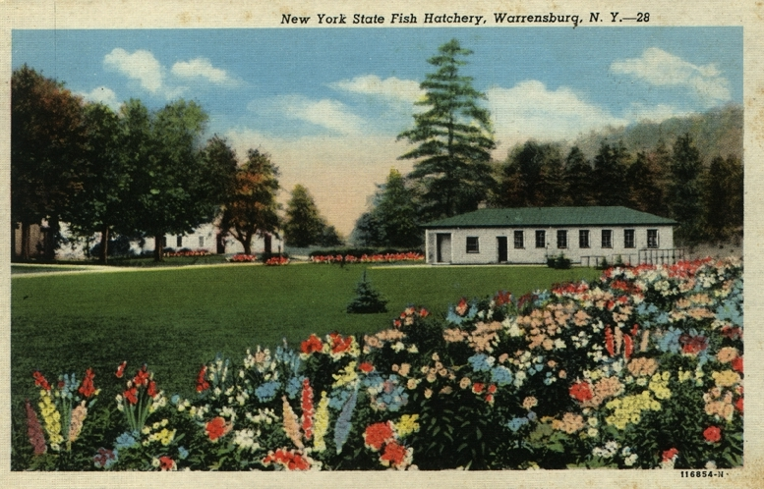

Warren County Fish Hatchery

Courtesy of Warrensburg Heritage Trail

This meeting is scheduled for May 14th from 9:00 a.m. to 11:00 a.m. at the Warren County Municipal Complex, 3rd Floor of the Human Resources Building. Same room as last time.

Agenda

1. Introductions
2. Follow up from last meeting
3. Warren County 2040 Comprehensive Plan
4. 2025 Activities
   * CSC Bronze recertification submitted, will hear back in June
   * CSC composting pilot program MWRR education grant
   * Grant applications
5. Partnership List and Public Outreach
6. Open discussion
7. Next meeting date: TBD